**Practical-9**

**Aim:**- **Implementation of K Mean Clustering and Unclustering on Jupyter Notebook using Python.**

In [1]:

# import matplotlib.pyplot as plt import pandas as pd

**import seaborn as sns**

In [2]:

iris = sns.load_dataset('iris') labels = iris.species.unique() iris.head()

Out[2]:

**sepal_length sepal_width petal_length petal_width species**

**0** 5.1 3.5 1.4 0.2 setosa

**1** 4.9 3.0 1.4 0.2 setosa

**2** 4.7 3.2 1.3 0.2 setosa

**3** 4.6 3.1 1.5 0.2 setosa

**4** 5.0 3.6 1.4 0.2 setosa

In [3]:

iris["species"] = pd.Categorical(iris["species"]) iris["species"] = iris["species"].cat.codes iris.head()

Out[3]:

**sepal_length sepal_width petal_length petal_width species**

**0** 5.1 3.5 1.4 0.2 0

**1** 4.9 3.0 1.4 0.2 0

**2** 4.7 3.2 1.3 0.2 0

**3** 4.6 3.1 1.5 0.2 0

**4** 5.0 3.6 1.4 0.2 0

In [15]:

X = iris[['sepal_length','sepal_width']].values y = iris.species

In [17]:

**from sklearn.cluster import** KMeans model = KMeans(n_clusters = 3).fit(X) centers = model.cluster_centers_ new_labels = model.labels_

In [18]:

print('Centroids :',centers) print('**\n**Labels :',new_labels)

Centroids : [[5.77358491 2.69245283]

[6.81276596 3.07446809]

[5.006 3.428 ]]

Labels : [2 2 2 2 2 2 2 2 2 2 2 2 2 2 2 2 2 2 2 2 2 2 2 2 2 2 2 2 2 2 2 2 2 2 2 2 2

2 2 2 2 2 2 2 2 2 2 2 2 2 1 1 1 0 1 0 1 0 1 0 0 0 0 0 0 1 0 0 0 0 0 0 0 0

1 1 1 1 0 0 0 0 0 0 0 0 1 0 0 0 0 0 0 0 0 0 0 0 0 0 1 0 1 1 1 1 0 1 1 1 1

1 1 0 0 1 1 1 1 0 1 0 1 0 1 1 0 0 1 1 1 1 1 0 0 1 1 1 0 1 1 1 0 1 1 1 0 1

1 0]

In [19]:





plt.figure(figsize=(12,8))

plt.scatter(X[:, 0], X[:, 1],c=y, s=60) plt.xlabel('Sepal length', fontsize=18) plt.ylabel('Sepal width', fontsize=18) plt.title('Unclustered Data',fontsize=18)

Out[19]:

Text(0.5, 1.0, 'Unclustered Data')

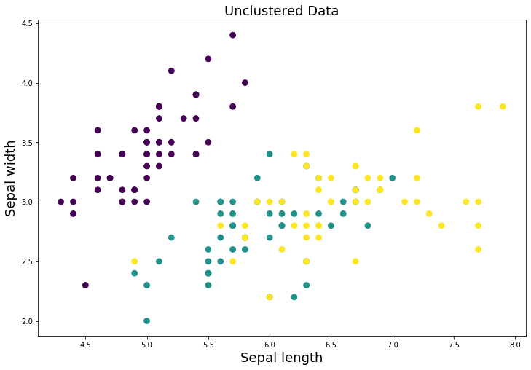

In [20]:



plt.figure(figsize=(12,8))

plt.scatter(X[:, 0], X[:, 1], c=new_labels,s=60)

plt.scatter(centers[:, 0], centers[:, 1], c='r', s=400, marker = '*', zorder=10); plt.xlabel('Sepal length', fontsize=18)

plt.ylabel('Sepal width', fontsize=18) plt.title('Clustered Data',fontsize=18)

Out[20]:

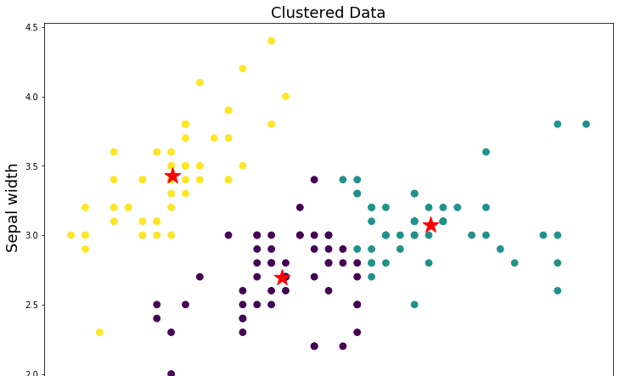Text(0.5, 1.0, 'Clustered Data')



In [21]:

y_pred = model.predict([[2.3,5.6]]) print("Result :",labels[y_pred[0]])

Result : virginica

In [ ]: